GeoTIFF Format

for IRS

Digital Data Products

July 2002

Data Products Software Division
Signal and Image Processing Group
SAC/ ISRO

AHMEDABAD – 380 015

Government of India
Space Applications Centre (ISRO)
Ahmedabad-380 015

Document Control and Data Sheet

1. Document No & Date : IRS/DP/SAC/SIIPA/SIPG/TN-07 /July 2002
2. Title : GeoTIFF format for IRS Digital Data Products
3. Type of Document : Technical
4. No. of pages : 25
5. Authors : IRS DP Team Compiled by : Sk.Sazid Mahammad
6. Originating Unit : Signal & Image Processing Group, Signal, Image & Information Processing Area
7. Security Classification : Unrestricted
8. Distribution : To identified individuals within ISRO/DOS and IRS Data Users

5NTENTS
Page No
1.0 Introduction 4

2.0 TIFF 5
2.1 Overview of TIFF File Structure 5
2.2 Baseline TIFF 10
2.3 Extended TIFF 10

3.0 Brief description GeoTIFF
3.1 Basic Features 15
3.2 GeoTIFF System/Software requirements 16
3.3 GeoTIFF File and “Key” structure Hierarchy 16
3.4 Where to get GeoTIFF specification 20

4.0 IRS - DPS Usage
4.1 File naming conventions. 21
4.2 Ellipsoids and Map projections supported. 22
4.3 Contents of a typical IRS GeoTIFF product. 24

1.0 Introduction
The spaceborn remote sensing images in digital form has gained wide spread popularity, over the last decade with the advances in the field of Digital Image Processing and Geographical Information System (GIS) and evolution of computer hardware and software. Although currently various data formats (e.g. PGM, GIF, BMP, TIFF) are in use for storage of raster image data, they have a common limitation in cartographic applications. The main problem is that, it is almost impossible to store any geographic information together with image data in a unified and well-defined way in the above mentioned formats. There was a requirement to develop a new standard or the extension of an existing one, by adding a formalism to store information about geo-location of the image, the underlying cartographic model, a set of tie points and other relevant data. This new format was required to have platform independency, flexibility and extensibility. The Aldus-Adobe's public domain Tagged Image File Format (TIFF) is one of the widely used raster file formats, which is platform independent and has provision for extension. In 1990 one positive initiative was started by the Intergraph Corp. and the JPL Cartographic Working Group, based on the TIFF standard. The basic idea was to exploit the extensibility feature of TIFF which allows to officially register new TIFF Tags in order to create a well established structured format/space for a variety of geographic information.
Though it is very difficult to standardize remote sensing satellite digital image data products' formats and its contents, GeoTIFF format is an effort for this considering widespread application of GIS packages worldwide. The basic idea behind this file format is to supplement the bare image data with all information necessary for the transformation from image space into a geographic or cartographic coordinate system.
This document has been written keeping IRS series Data Products contents in GeoTIFF format. The aim of this document is not to give complete TIFF or GeoTIFF specification, but only the fields used to give details of a given IRS data product. For a full understanding of GeoTIFF, this document has to be read along with the original GeoTIFF (Revision 1.0) specification. The GeoTIFF specification can be down loaded from the site given in chapter 3.

2.0 TIFF (Tagged Image File Format)

TIFF (Tagged Image File Format), is a tag-based file format for storing and interchanging raster images. The first version of TIFF specification was published by Aldus Corporation in 1986, after a series of meetings with various scanner manufactures and software developers. TIFF is to describe and store raster image data. The main advantages of TIFF is its suitability for a wide range of applications and its independence of computer's architecture, operating system, and graphics hardware. It is reasonably compact and handles black-and-white, grayscale, and color images, allowing a user to adjust for the unique characteristics of a scanner, monitor, or printer. TIFF allows color resolution up to 48 bits (a 16-bit field each for R, G, and B), either as full RGB color or in a 64k-color palette .The TIFF 6.0 specification, released in June 1992 is taken as reference by GeoTIFF.
There are two variants in revision 6.0 of TIFF: baseline and extended TIFF. Within both these variants, there are many optional capabilities. Furthermore, TIFF data vary according to photometric type and compression method. All TIFF 6.0 readers and writers must handle the baseline set of data fields. The way in which these data fields are handled, depends on whether they are mandatory or optional.

2.1 Overview of TIFF File Structure
The TIFF format has a three-level hierarchy. From highest to lowest, the levels are:
1) A file Header.
2) One or more directories called IFDs, containing codes and their data, or pointer to the data.
3) Data.
The graphical view of TIFF file structure is given in Fig.1.
The File Header
The TIFF file begins with an 8-byte header which gives basic information about the file such as byte order (Little Endian or Big Endian), TIFF file ID or Version Number (which is always 42) and a pointer to first Image File Directory (IFD). The structure of TIFF file header is as follows:
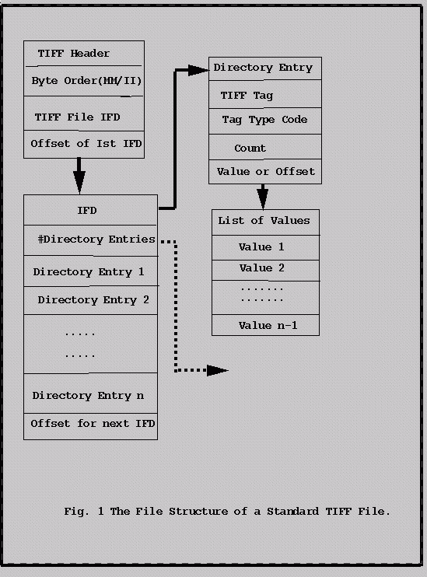
TABLE : 1 TIFF file Header
Offset | Length | Description
0 | 2 | Byte Order: MM or II
2 | 2 | "Version number ":  which is always 42
4 | 4 | Pointer to first IFD

* Byte Order Field : The first header entry is in byte counts 0 and 1. It is a two-letter ASCII record containing the codes for the letters MM or II (4D4D hex or 4949 hex, respectively). MM stands for Motorola architecture, signifying that bytes comprising 16, 32 0r 64 bit numbers are stored in the order of most-to-least significant (big endian). II denotes file created in the Intel Architecture, where bytes are stored in the least-to-most significant order (little endian). By reading this record , a Mac or UNIX workstation-based file reader can detect a file created on a PC or vice versa, and interpret it properly.
* Version field : The second header entry, a two byte number termed Version in the specification, actually has nothing to do with any version number or with the revision number of the specification. It is always the decimal number 42 (2A hex). For practical purposes, this code identifies the file as a TIFF file.
* First IFD Offset pointer : The final header entry is a 4-byte pointer to the location of the first Image File Directory (IFD). The order of bytes here, as elsewhere, depends on the MM or II designation in the first entry. This pointer begins at an offset of 4, the fifth byte in the file.
Image File Directories (IFDs)
Most Likely, the next structure in the file after the header will be the first (or only) IFD, but not necessarily. From here on, everything is found by following pointers. So, to locate the first IFDuse the header's pointer.
An IFD consists of 12-byte entries, typically tagged pointers. The structure of an IFD and its entries are as follows:

TABLE : 2 TIFF IFD Structure
Offset | Length | Description
0 | 2 | Entry Count
2 | 12 | Entry 0
14 | 12 | Entry 1
. | . | .
. | . | .
n*12 +2 | 12 | Entry n
n*12 + 2 + 12 | 4 | Pointer to subsequent IFD, if any, or 0000

* Entry Count field : Since there may be any number of IFD entries, the first field in an IFD is a 2-byte count of number of entries.
* IFD entries : IFD entries are 12-byte fields, beginning with the tag code that specifies what type of data are present. The entries are ordered numerically within the IFD, according to the tag numbers, a feature that helps TIFF readers quickly determine which fields are present and which are not.
* Terminating field : The last entry in an IFD will be four bytes of zero, unless there is more than one IFD. If there is more than one IFD, the last entry of the preceding IFD contains a 4-byte pointer to the next one.
TABLE : 3 TIFF IFD Entry Structure

Offset | Length | Description
0 | 2 | Tag
2 | 2 | Type of Data
4 | 4 | Count field
8 | 4 | Data pointer or data field
* Tag : The first two bytes are tag, which , if public , may be looked up in the specification. These codes are assigned by the TIFF administrator ( Aldus Developer's Desk), in blocks of five.
* Type code : The next two bytes comprise a code indicating the type of data in the pointed field. Note that some tags allow a variety types, so TIFF readers should always check this code. TIFF 6.0 supports a veriety of data types ; the codes, the data types, and their names are as follows :
TABLE : 4 TIFF 6.0 DATA TYPES
Data Type Code | No of Bytes | Standard Data Type
1 | 1-byte integer | type BYTE
2 | 1-byte integer, ASCII | type ASCII
3 | 2-byte integer | type SHORT
4 | 4-byte integer | type LONG
5 | 8-byte fraction | type RATIONAL (4-byte numerator followed by 4-byte denominator)
6 | 1-byte signed integer | type SBYTE
7 | 1-byte of anything | type UNDEFINED, e.g. a pointer to a complex data structure.
8 | 2-byte signed integer | type SSHORT
9 | 4-byte signed long | type SLONG
10 | 8-byte signed fraction | type SRATIONAL, SLONG numerator, SLONG denominator.
11 | 4-byte floating point | type FLOAT, IEEE format
12 | 8-byte floating point | type DOUBLE, double-precision IEEE

* Count field : The 4-byte field specifies the number of values in the data field, not the number of bytes. The number of bytes can be computed by multiplying the count by the number of bytes in the data type. For example, a count of 64 with a data type of LONG means there will be 256 bytes. ( The count was referred to as the length in earlier revisions of TIFF.)
* Data pointer or data field : The final four bytes are usually a pointer to the start of a data field. Sometimes, however, this field contains not a pointer, but the actual data. If there are four bytes of data or less, as computed by the product of count and the byte count indicated by type, then the field contains data. Otherwise, the field is a pointer ( the offset in bytes from the start of the file to the start of the data field).
2.2 Baseline TIFF
Baseline TIFF specification mostly affects TIFF readers. TIFF readers must be able to process all the fields given in baseline table or must assume the specified default, if the field is not present, regardless of the image-type expected. TIFF writers must include all fields required for the type of image data written, except where the default value is desired. Refer Table 5 and Table 6 for details of TIFF 6.0 Tags.
2.3 Extended TIFF
TIFF 6.0 defines numerous extensions. These allow TIFF to offer the following general capabilities.
* Alternative compression schemes : CCITT, LZW(with and without differencing), and JPEG.
* Alternative color-representation schemes: CMYK, YCbCr, and CIE L*a*b*.
* Image-quality enhancements : Halftone "hinting," RGB colorimetry.
* Special image effects : Alpha data ( mating, masks and overlays), tiled images.
* Document storage and retrieval aids: document and page names, page numbers, and position on the page.
These extensions take the form of additional tags and/or special codes for baseline tags.

Baseline TIFF Tags its usage in IRS DPS
IRS-DPS uses Grayscale model to store image data. For each band of data a separate file with band name is given. In the following table the relevant/used fields of TIFF in context of IRS has been indicated.
Following fields may change or contain no information as per changes in DPS s/w and team members.
Extra Fields.
Software(305), DateTime(306), Artist(315), HostComputer(316).

Mandetory/required fields and their defaults. X indicates field must be written in TIFF file for given image type(Bi-level,Grayscale,Palette,RGB).

TABLE : 5
Field /Tag Name | TagValue | Default | Bi-level | Grayscale | Palette | RGB | IRS-1C/1D/P6( DPSUSE)  Grayscale/RGB
ImageWidth | 256 | none | X | X | X | X | Yes
ImageLength | 257 | none | X | X | X | X | Yes
BitsPerSample | 258 | 1 |  | X | X | X | Yes
ColorMap | 320 | none |  |  | X |  | NotApplicable
Compression | 259 | 1 | X | X | X | X | Yes
PhotometricInterpretation | 262 | none | X | X | X | X | Yes
StripOffsets | 273 | none | X | X | X | X | Yes
RowsPerStrip | 278 | (2**32)-1 | X | X | X | X | Yes
StripByteCounts | 279 | none | X | X | X | X | Yes
Xresolution | 282 | none | X | X | X | X | Yes
Yresolution | 283 | none | X | X | X | X | Yes
ResolutionUnit | 296 | 2 | X | X | X | X | Yes

All Baseline field s/tags of TIFF 6.0 and IRS DPS Usage.
TABLE : 6
Tag Name | TagValue | IRS-1C/1D  (DPSUse ) | Remarks in IRS DPS Context
NewSubFileType | 254 | No
SubFileType | 255 | No
ImageWidth | 256 | Yes | Gives PixelsPerScanline or RecordLength.
ImageLength | 257 | Yes | Gives No of ScanLines in the given image.
BitsPerSample | 258 | Yes | For IRS DPS this is 8 since image data is 8bit.
Compression | 259 | Yes | Code 1 is used in DPS showing no compression
PhotometricInterpretation | 262 | Yes | 1: in GrayScale  2: in RGB
Thresholding | 263 | No
CellWidth | 264 | No
CellLength | 265 | No
FillOrder | 266 | No
DocumentName | 269 | Yes
ImageDescription | 270 | Yes | Gives EOSAT/ISRO Fast Format Header
Make | 271 | No
Model | 272 | No
StripOffsets | 273 | Yes
Orientation | 274 | Yes | Code 1 is used : FisrtRowOnTop &FirstColumnOnLeft
SamplesPerPixel | 277 | No: GrayScale  Yes : in RGB | GrayScale : NA  RGB : 3
RowsPerStrip | 278 | Yes
StripByteCounts | 279 | Yes
MinSampleValue | 280 | Yes | Minimum possible gray value ( "0" for IRS)
MaxSampleValue | 281 | Yes | Maximum possible Gray Value ("255" for IRS)
Xresolution | 282 | Yes | Number of pixels in one ResolutionUnit
Yresolution | 283 | Yes | No Of ScanLines in one ResolutionUnit
PlanarConfiguration | 284 | No | data i/o
PageName | 285 | No
Xposition | 286 | No
Yposition | 287 | No
FreeOffsets | 288 | No
FreeByteCounts | 289 | No
GrayResponseUnit | 290 | No
GrayResponseCurve | 291 | No
Group3Options | 292 | No
Group4Options | 293 | No
ResolutionUnit | 296 | Yes | Code 3 is used to indicate unit as Centimeters.
PageNumber | 297 | No
ColorResponseUnit | 300 | No
TransferFunction | 301 | No
Software | 305 | Yes | Software Release Number/Description.
DateTime | 306 | Yes | Date and Time of Product generation.
Artist | 315 | Yes | Authors name and organization name is give.
HostComputer | 316 | Yes | Processing System/Center Name is given.
Predictor | 317 | No
WhitePoint | 318 | No
PrimaryChromacities | 319 | No
ColorMap | 320 | No
TileWidth | 322 | No
TileLength | 323 | No
TileOffsets | 324 | No
TileByteCounts | 325 | No
BadFaxLines | 326 | No
CleanFaxData | 327 | No
ConsecutiveBadFaxLines | 328 | No
SubIFD | 330 | No
InkSet | 332 | No
InkNames | 333 | No
DotRange | 336 | No
TargetPrinter | 337 | No
ExtraSamples | 338 | No
SampleFormat | 339 | No
SminSampleValue | 340 | No
SmaxSampleValue | 341 | No
JPEGTables | 347 | No | used by JPEG codec
YcbCrCoefficients | 529 | No | used by TIFFReadRGBAImage support
YcbCrSubsampling | 530 | No | tile/strip size calculations
YcbCrPositioning | 531 | No
ReferenceBlackWhite | 532 | No
Matteing | 32995 | No | none (obsoleted by ExtraSamples tag)
DataType | 32996 | No | none (obsoleted by SampleFormat tag)
ImageDepth | 32997 | No | tile/strip calculations
TileDepth | 32998 | No | tile/strip calculations

3.0 Brief Description of GeoTIFF

The GeoTIFF specification defines a set of TIFF tags provided to describe all "Cartographic" information associated with TIFF imagery that originates from satellite imaging systems, scanned aerial photography, scanned maps, digital elevation models, or as a result of geographic analyses. Its aim is to allow means for tying a raster image to a known model space or map projection.
GeoTIFF does not intend to become a replacement for existing geographic data interchange standards, such as the USGS SDTS standard or the FGDC metadata standard. Rather, it aims to augment an existing popular
raster-data format to support georeferencing and geocoding information.
3.1 Basic Features
GeoTIFF format fully complies with the TIFF 6.0 specifications, and its extensions do not in any way go against the TIFF recommendations, nor do they limit the scope of raster data supported by TIFF.
It uses a small set of reserved TIFF tags to store a broad range of georeferencing information, catering to geographic as well as projected coordinate systems needs. Projections include UTM, US State Plane and
National Grids, as well as the underlying projection types such as Transverse Mercator, Lambert Conformal Conic, etc.
It uses a "MetaTag" (GeoKey) approach to encode dozens of information elements into just 6 tags, taking advantage of TIFF platform-independent data format representation to avoid cross-platform interchange difficulties. These keys are designed in a manner parallel to standard TIFF tags, and closely follow the TIFF discipline in their structure and layout. New keys may be defined as needs arise, within the current framework, and without requiring the allocation of new tags from Aldus/Adobe.
GeoTIFF format uses numerical codes to describe projection types, coordinate systems, datums, ellipsoids, etc. The projection, datums and ellipsoid codes are derived from the EPSG list compiled by the Petrotechnical Open Software Corporation (POSC), and mechanisms for adding further international projections, datums and ellipsoids has been established. The GeoTIFF information content is designed to be compatible with the data decomposition approach used by the National Spatial Data Infrastructure (NSDI) of the U.S. Federal Geographic Data Committee (FGDC).

3.2 GeoTIFF System/Software Requirements
GeoTIFF requires support for all documented TIFF 6.0 tag data-types, and in particular requires the IEEE double-precision floating point "DOUBLE" type tag. Most of the parameters for georeferencing will not have
sufficient accuracy with single-precision IEEE, nor with RATIONAL format storage. The only other alternative for storing high-precision values would be to encode as ASCII, but this does not conform to TIFF recommendations for data encoding.
It is worth emphasizing here that the TIFF spec indicates that TIFF-compliant readers shall honor the 'byte-order' indicator, meaning that 4-byte integers from files created on opposite order machines will be swapped in software, and that 8-byte DOUBLE's will be 8-byte swapped.
A GeoTIFF reader/writer, in addition to supporting the standard TIFF tag types, must also have an additional module which can parse the "Geokey" MetaTag information
3.3 GeoTIFF File and "Key" Structure Hierarchy
This gives the abstract file-format and "GeoKey" data storage mechanism used in GeoTIFF. To see graphical view of the GeoTIFF file structure please refer Fig. 2.
A GeoTIFF file is a TIFF 6.0 file, and inherits the file structure as described in the corresponding portion of the TIFF spec. All GeoTIFF specific information is encoded in several additional reserved TIFF tags, and contains no private Image File Directories (IFD's), binary structures or other private information invisible to standard TIFF readers.
The number and type of parameters that would be required to describe most popular projection types would, if implemented as separate TIFF tags, likely require dozens or even hundred of tags, exhausting the limited resources of the TIFF tag-space. On the other hand, a private IFD, while providing thousands of free tags, is limited in that its tag- values are invisible to non-savvy TIFF readers (which don't know that the IFD_OFFSET tag value points to a private IFD).
To avoid these problems, a GeoTIFF file stores projection parameters in a set of "Keys" which are virtually identical in function to a "Tag", but has one more level of abstraction above TIFF. Effectively, it is a sort of "Meta-Tag". A Key works with formatted tag-values of a TIFF file the way that a TIFF file deals with the raw bytes of a data file. Like a tag, a Key has an ID number ranging from 0 to 65535, but unlike TIFF tags, all key ID's are available for use in GeoTIFF parameter definitions.
The Keys in GeoTIFF (also call "GeoKeys") are all referenced from the GeoKeyDirectoryTag, which defined as follows:
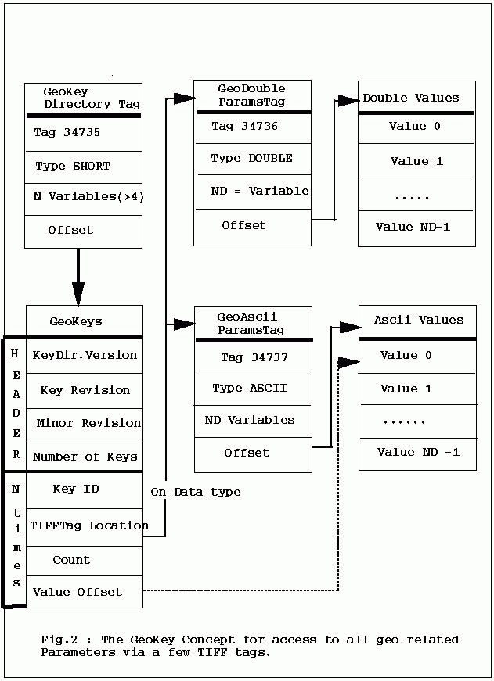
GeoKeyDirectoryTag:
Tag = 34735 (87AF.H)
Type = SHORT (2-byte unsigned short)
N = variable, >= 4
Alias : ProjectionInfoTag, CoordSystemInfoTag
Owner: SPOT Image, Inc.
This tag may be used to store the GeoKey DirecGeoKey directory header information. The header values consist of the following information, in order:
Header={KeyDirectoryVersion, KeyRevision, MinorRevision, NumberOfKeys}
where
"KeyDirectoryVersion" indicates the current version of Key implementation, and will only change if this Tag's Key structure is changed. (Similar to the TIFFVersion (42)). The current DirectoryVersion number is 1. This value will most likely never change, and may be used to ensure that this is a valid Key-implementation.
"KeyRevision" indicates what revision of Key-Sets are used.
"MinorRevision" indicates what set of Key-codes are used. The complete revision number is denoted <KeyRevision>.<MinorRevision>
"NumberOfKeys" indicates how many Keys are defined by the rest of this Tag.
This header is immediately followed by a collection of <NumberOfKeys> KeyEntry sets, each of which is also 4-SHORTS long. Each KeyEntry is modeled on the "TIFFEntry" format of the TIFF directory header, and is
of the form:
KeyEntry = { KeyID, TIFFTagLocation, Count, Value_Offset }
where
"KeyID" gives the key-ID value of the Key (identical in function to TIFF tag ID, but completely independent of TIFF tag-space),
"TIFFTagLocation" indicates which TIFF tag contains the value(s) of the Key: if TIFFTagLocation is 0, then the value is SHORT, and is contained in the "Value_Offset" entry. Otherwise, the type (format) of the value is implied by the TIFF-Type of the tag containing the value.
"Count" indicates the number of values in this key.
"Value_Offset" Value_Offset indicates the index- offset *into* the TagArray indicated by TIFFTagLocation, if
it is nonzero. If TIFFTagLocation=0, then Value_Offset contains the actual (SHORT) value of the Key, and
Count=1 is implied. Note that the offset is not a byte-offset, but rather an index based on the natural data type of the
specified tag array.
Following the KeyEntry definitions, the KeyDirectory tag may also contain additional values. For example, if a Key requires multiple SHORT values, they shall be placed at the end of this tag, and the KeyEntry will set TIFFTagLocation=GeoKeyDirectoryTag, with the Value_Offset pointing to the location of the value(s).
All key-values which are not of type SHORT are to be stored in one of the following two tags, based on their format:tory, which defines and references the "GeoKeys", as described below.
The tag is an array of unsigned SHORT values, which are primarily grouped into blocks of 4. The first 4 values are special, and contain
GeoDoubleParamsTag:
Tag = 34736 (87BO.H)
Type = DOUBLE (IEEE Double precision)
N = variable
Owner: SPOT Image, Inc.
This tag is used to store all of the DOUBLE valued GeoKeys, referenced by the GeoKeyDirectoryTag. The meaning of any value of this double array is determined from the GeoKeyDirectoryTag reference pointing to it. FLOAT values should first be converted to DOUBLE and stored here.
GeoAsciiParamsTag:
Tag = 34737 (87B1.H)
Type = ASCII
Owner: SPOT Image, Inc.
N = variable
This tag is used to store all of the ASCII valued GeoKeys, referenced by the GeoKeyDirectoryTag. Since keys use offsets into tags, any special comments may be placed at the beginning of this tag. For the most part, the only keys that are ASCII valued are "Citation" keys, giving documentation and references for obscure projections, datums, etc.
Note on ASCII Keys:
Special handling is required for ASCII-valued keys. While it is true that TIFF 6.0 permits multiple NULL-delimited strings within a single ASCII tag, the secondary strings might not appear in the output of naive "tiffdump" programs. For this reason, the null delimiter of each ASCII Key value shall be converted to a "|" (pipe) character before being installed back into the ASCII holding tag, so that a dump of the tag will look like this.
AsciiTag="first_value|second_value|etc...last_value|"
A baseline GeoTIFF-reader must check for and convert the final "|" pipe character of a key back into a NULL before returning it to the client software.

3.4 Where to get GeoTIFF Specification
Following are the sites where details of GeoTIFF spec. is available.
EPSG/POSC tables, and source code is available via anonymous FTP at:
ftp://mtritter.jpl.nasa.gov/pub/tiff/geotiff/
and is mirrored at the USGS:
ftp://ftpmcmc.cr.usgs.gov/release/geotiff/jpl_mirror/
There are several subdirectories called spec/ tables/ and code/.
The USGS also has an archive of prototype GeoTIFF images at:
ftp://ftpmcmc.cr.usgs.gov/release/geotiff/images/
Information and a hypertext version of the GeoTIFF spec is available via WWW at the following site:
http://www-mipl.jpl.nasa.gov/cartlab/geotiff/geotiff.html
A mailing-list is currently active to discuss the on-going development of this standard. To subscribe to this list, send e-mail to:
GeoTIFF-request@tazboy.jpl.nasa.gov
with no subject and the body of the message reading:
subscribe geotiff your-name-here
To post inquiries directly to the list, send email to:
geotiff@tazboy.jpl.nasa.gov

4.0. IRS DPS Usage : Both TIFF and GeoTIFF Conventions

Following file naming conventions are used in Data Products of IRS – 1C/1D
4.1 File Naming Convention
IRS -1C/1D has three sensors namely LISS-3, PAN and WiFS.
IRS – P6 has also three sensors namely LISS-3, LISS-4, AWiFS.
Liss-3, LISS-4,WiFS , AWiFS
BANDn.tif where n =2,3,4,5 for LISS-3 , AWiFS,
= 2,3,4 for LISS-4.
= 3,4 for WiFS.
For example a 4 band LISS-3/AWiFS product in Gray scale will contain following four files:
BAND2.tif
BAND3.tif
BAND4.tif
BAND5.tif
In case of RGB model only three bands 2, 3, and 4 can be choosen. So a single tiff file will be generated by the name BAND_RGB.tif. In RGB model image data is stored in BIP(Band Interleaved by Pixel) format.
A typical WiFS product will contain following file.
BAND3.tif
BAND4.tif
PAN
BAND.tif .
4.2 Ellipsoid and Map Projection supported
IRS-DPS uses Grayscale model to store image data. For each band of data a separate file with band name is given.
IRS Data Product supports various Ellipsoids and map projections.
Map Projections
Following map projections are supported in IRS-DPS.
Projection Name Mnemonic
Universal Transverse Mercator UTM
State Plane Coordinate System SPCS
Albers Conical Equal Area ACEA
Lambett's Conformal Conic LCC
Mercator MER
Polar Stereographic PS
Polyconic PC
Equidistant Conic (Type A & B) EC
Transverse Mercator (Gauss-Krueger) TM
Stereographic SG
Lamberts Azimuthal Equal Area LAEA
Azimuthal Equidistant AE
Gnomonic GNO
Orthographic OG
General Vertical Near-Side Perspective GVNP
Sinusoidal SIN
Equirectangular (Plate Carree) ER
Miller Cylindrical MC
Van Der Grintern I VDG
Oblique Mercator (Type A & B) OM
Space Oblique Mercator SOM

Earth Ellipsoids
This appendix contains the earth ellipsoids used in products.
This list of ellipsoids shows the name and the identifier used in Record
3. Field 3 of the header file.
Ellipsoid Name Semi-Major Axis Semi-Minor Axis Mnemonic
(meters) (meters)
Clarke 1866 6378206.400000 6356583.800000 CLARKE_1866
Clarke 1880 6378249.145000 6356514.869550 CLARKE_1880
International1967 63778157.50000 6356772.200000 INTERNATL_1967
International 6378388.000000 6356911.946130 INTERNATL_1909
WGS 66 6378145.000000 6356759.769356 WGS_66
WGS 72 6378135.000000 6356750.519915 WGS_72
WGS 84 6378137.000000 6356752.314000 WGS_84
GRS 1980 6378137.000000 6356752.314140 GRS_80
Airy 6377563.396000 6356256.910000 AIRY
Modified Airy 6377340.189000 6356034.448000 MODIFIED_AIRY
Everest 6377276.345200 6356075.413300 EVEREST
Modified Everest 6377304.063000 6356103.039000 MODIFIED_EVEREST
Mercury 1960 6378166.000000 6356784.283666 MERCURY_1960
Modified Mercury 6378150.000000 6356768.337303 MOD_MERC_1968
Bessel 6377397.155000 6356078.962840 BESSEL
Walbeck 6376896.000000 6355834.846700 WALBECK
Southeast Asia 6378155.000000 6356773.320500 SOUTHEAST_ASIA
Australian Natl. 6378160.000000 6356774.719000 AUSTRALIAN_NATL
Krassovsky 6378245.000000 6356863.018800 KRASSOVSKY
Hough 6378270.000000 6356794.343479 HOUGH
6370997 Sphere 6370997.000000 6370997.000000 6370997_M_SPHERE

4.3 Contents of a typical IRS GeoTIFF Product
The content of a Geocoded product in GeoTIFF format and various fields are shown below.
The various fields of TIFF used by IRS Data Products are as follows:

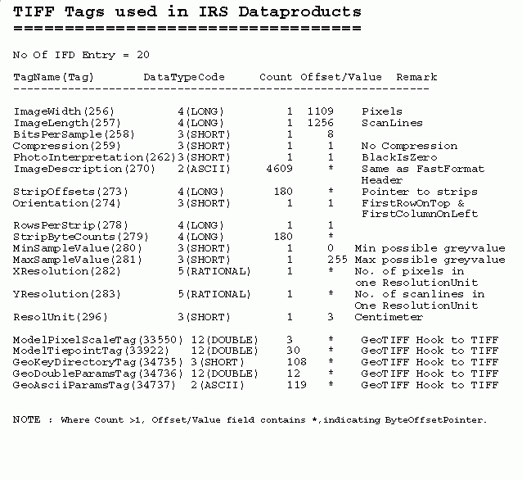

The various fields of GeoTIFF used by IRS Data Products are as follows:

